Delta has a requirement to ship a specific amount of ‘touch up paint’ with each order. The qty of touch up paint needed is based on the total linear feet per finish.

On a customer order, there can be various types of finishes on the line items as shown in the screenshot below. This is CO102289 in Production.

I didn’t find the order in production. Please suggest.

\*\*\* Sorry, not sure where that order went to lol. You can use CO101449 in Sandbox.

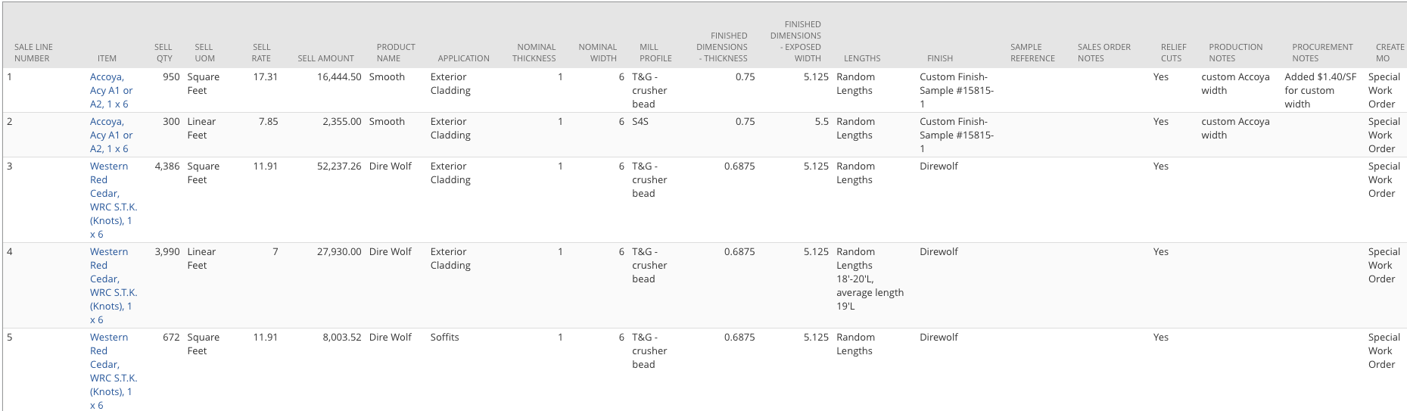

We will want to have a scheduled script that runs nightly to determine the total amount of touch up paint required for each finish per customer order.

Okay Mike.

If the Finish field on the customer order line is NULL or contains the value of Unfinished, then that line can be ignored from this customization.

Okay Mike.

There will be a new item created titled Touch Up Paint (already created in sandbox. Internal ID 933).

Okay Mike.

There will be a custom table that will hold the details of how to determine amount of touch up paint required based on linear feet (see details below).

Mike, I didn’t find the custom table. Do we need to create it? What are the fields we need to use in the custom table?

\*\*\* Yes, we need to create the table. Details are listed below.

There will be a checkbox at the header level of the order titled ‘Touch Up Processed’.

Okay Mike, I will create it.

The guidelines for determining the amount of finish is as follows:

1-1499 linear feet = 1 qt

1500-2499 = 2 qt

2500-3999 = 1 gallon

4000 - 8000 = 2 gallon

8001 - 11000 = 3 gallon

11001 - 14000 = 4 gallons

Over 14000 = 5 gallons

When the script runs it will:

* The script will look for orders created that day.
* Group lines on a customer order by finish, so in the screenshot above there would be two groupings. One for Custom Finish- Sample #15815-1 and one for Direwolf.
* Add the total Qty on the lines by Finish. Example: In the order above, Custom Finish-Sample #15815-1 would have a total of 2,524.4 linear feet and Direwolf would have a total of 16,323.2 linear feet.
* A new line item would be created on the customer order for each Finish. The item used would be the new Touch Up Paint item. The qty for these new lines would be 1 and amount would be 0. We would populate the details in the Description field on the line. Example: In the screenshot above two new lines would be added.
  + Item: Touch Up Paint, Qty: 1, Amount: $0.00, Description: Custom Finish- Sample #15815-1, 2,524.4 Linear Feet, 1 Gallon and applicator bottle. (calculation will be used to determine the amount of touch up paint needed).
  + Item: Touch Up Paint, Qty: 1, Amount: $0.00, Description: Direwolf, 16,323.2 linear feet, 5 Gallons.
* After new lines have been added then check the Touch Up Processed box at the header of the customer order.

Mike, so the line item on the customer order will be as below and advise.

Item: Touch Up Paint

Qty: 1,

Amount: 0.00,

Description: Custom Finish- Sample #15815-1, 2,524.4 Linear Feet, 1 Gallon and applicator bottle

Item: Touch Up Paint

Qty: 1,

Amount: 0.00,

Description: Direwolf, 16,323.2 linear feet, 5 Gallons.

\*\*\* That is correct